PPI TX Functional Design Specifications
  - MIPI CSI Controller IP
  - Version 1.0

  - Block Owner
Abdelrahman Elsayed
  - Authors
Abdelrahman Elsayed

This Page is left Blank Intentionally

Table of Contents
1 Table of Contents 1
2 Revision History 2
3 Overview 3
4 Operation and Description 3
4.1 Digital Interface 3
4.1.1 Parameters Names 3
4.1.2 Ports Names 3
4.2 Functional Description 3
4.3 Block Diagram 3
4.4 Timing Diagram 3
4.5 Verification Requirements 3

Revision History
Version | Date | Author(s) | Revision Notes | Owner Approval

Overview
The Protocol-to-PHY Interface Transmitter (PPI TX) is a core module within the MIPI CSI Controller IP. It serves as the primary bridge between the internal System Clock domain and the MIPI D-PHY High-Speed (HS) Clock domain. The module manages the transition to HS mode, handles Clock Domain Crossing (CDC) using Asynchronous FIFOs, and implements Ultra-Low Power Management (ULPM) and High-Speed Request sequencing to ensure fully compliant communication with the D-PHY Macro.

Operation and Description

Digital Interface

Parameters Names
Parameter Name | Default | Description
N/A | N/A | This module does not utilize top-level instantiation parameters. Internal FIFO dimensions are fixed at WIDTH=8, DEPTH=16.

Ports Names
Port Name | Port Width | Port Type | Description
i_clk_sys | 1 | Input | System core clock.
i_rst_n_sys | 1 | Input | Active-low asynchronous system reset.
i_rst_n_tx | 1 | Input | Active-low asynchronous TX/PHY reset.
i_active_lanes | 3 | Input | Configuration input defining the active lanes.
i_lane[0:3]_data | 8 | Input | Parallel plaintext or scrambled data from the TX pipeline.
i_lane[0:3]_vld | 1 | Input | Valid signals indicating active payload data for the corresponding lanes.
i_req_hs | 1 | Input | High-Speed mode transition request from the system controller.
o_TxClkRequestHS | 1 | Output | PPI High-Speed Clock Request sent to the D-PHY.
i_TxClkReadyHS | 1 | Input | PPI High-Speed Clock Ready acknowledgement from the D-PHY.
i_TxByteClkHS | 1 | Input | MIPI D-PHY High-Speed Byte Clock (Read domain clock).
o_TxRequestHS | 4 | Output | PPI High-Speed Data Request for lanes 0 to 3.
i_TxReadyHS | 4 | Input | PPI High-Speed Data Ready acknowledgement for lanes 0 to 3.
o_lane[0:3]_data_hs | 8 | Output | High-Speed data buses driving the D-PHY lanes.
o_lane[0:3]_valid_hs | 1 | Output | High-Speed valid signals driving the D-PHY lanes.
i_Shutdown | 1 | Input | Power-down / Shutdown command from the Register File (APB).
i_TxClkEsc | 1 | Input | Escape mode clock from the System PLL.
o_TxUlpmClk | 1 | Output | Ultra Low Power Mode (ULPM) Clock status signal to D-PHY.
o_TxRequestEsc | 4 | Output | Escape Request signals for lanes 0 to 3.
o_TxUlpmEsc | 4 | Output | Ultra Low Power Mode (ULPM) Escape signals for lanes 0 to 3.

Functional Description
The PPI TX module operates through several highly integrated sub-blocks to handle clock domains and physical layer protocols:
- High-Speed Clock Request & Keep-Alive Logic: To ensure a clean packet termination at the D-PHY level and prevent jitter, the module maintains the HS clock request (o_TxClkRequestHS) active for a programmable TCLK-POST period (configured here as ~40 cycles) after the core packet request (i_req_hs) drops.
- Data Path & Clock Domain Crossing (CDC): Uses 4 independent Asynchronous FIFOs to safely transport data from the i_clk_sys domain to the i_TxByteClkHS domain. The read operations from these FIFOs are strictly gated by the PPI handshake signals (o_TxRequestHS & i_TxReadyHS), guaranteeing that data is only driven when the PHY is fully ready.
- CIL Power Management Logic (ULPM Control): Dynamically manages the power state of the D-PHY. When the controller is idle (no i_req_hs and the Keep-Alive timer has expired) and i_Shutdown is inactive, the logic automatically triggers Ultra Low Power Mode (ULPM) by driving o_TxUlpmClk, o_TxRequestEsc, and o_TxUlpmEsc.
- Synthesis Optimization & EDA Sinks: Includes internal Dummy Flip-Flops and AND-reduction sinks for i_TxClkEsc and unused flags (like FIFO full states). This satisfies structural gate-level synthesis requirements (e.g., SpyGlass constraints) while ensuring no floating nets exist in the design.

Block Diagram
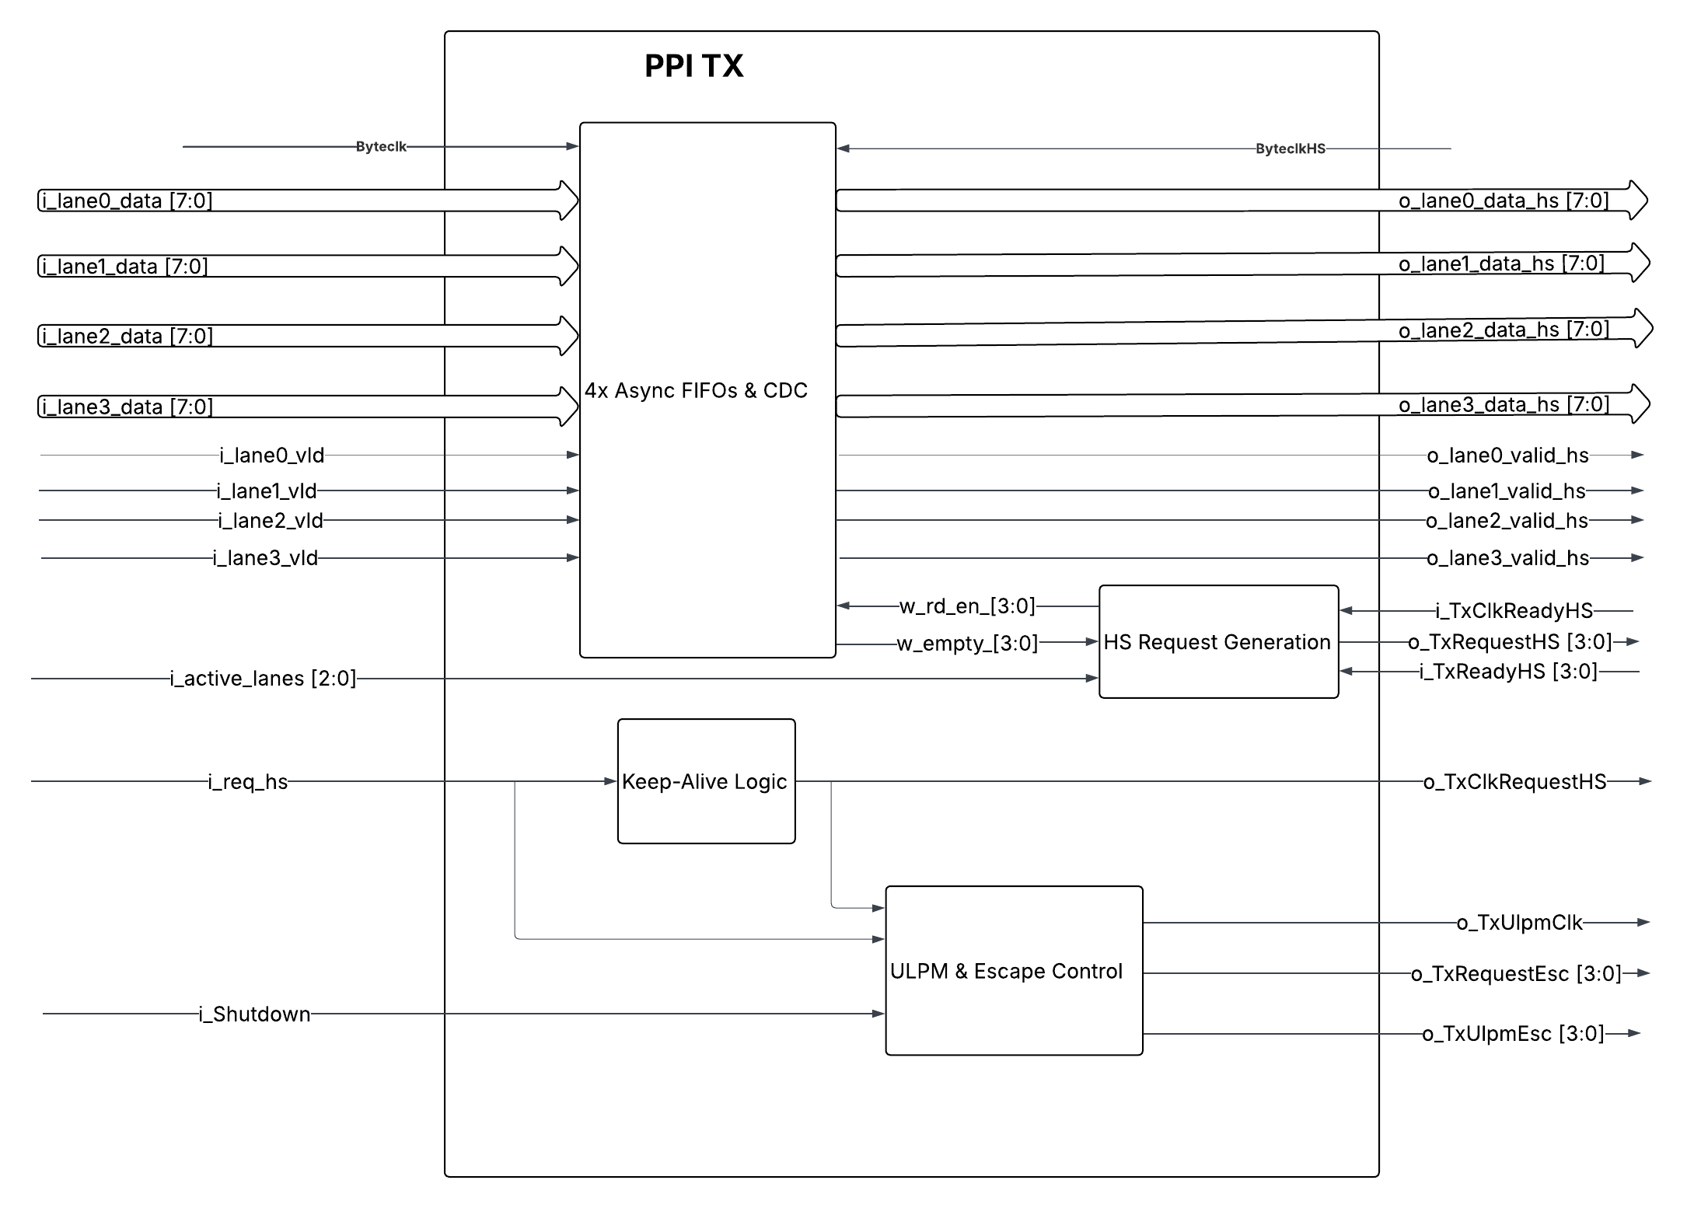

Timing Diagram
Any timing Diagrams that relate inputs/outputs together should be demonstrated here

Verification Requirements
